ATHLETICS NEW ZEALAND
Proposed changes to Competition Regulations
Discus Cage
The current Regulations contain the following basic statement about the discus cage. We are proposing to remove this and comply with World Athletics rules for the discus cage. It is proposed that this be removed from 1 October 2021.
Rule STR35 - Discus Cage
The cage must be designed to ensure adequate safety protection for the level of competition being undertaken, the physical layout of the competition venue and the actual competition programme.

Hammer Cage
Since 2004 New Zealand has had this supplementary rule using the IAAF 2003-2003 rule for the cage specification. These cages no longer comply with the current World Athletics rules, and this supplementary rule needs to be removed. Centres have been consulted and agree to this course of action. It is proposed that this supplementary rule be removed from 1 October 2021.
Rule STR37 - Hammer Cage
Safety Net Specifications: For New Zealand domestic competition the hammer cage specifications as set out in the IAAF Handbook 2002-2003 (Rule 192) may be used, with the exception of the gates which shall be 3.20m wide and at least 7m high.

Note:
- The cage must be designed to ensure adequate safety protection for the level of competition being undertaken, the physical layout of the competition venue and the actual competition programme.
- The relevant clauses of Rule 192 in the IAAF Handbook 2002-2003 are as follows:
  - "The cage should be U-shaped in plan as shown on the diagram. The width of the mouth should be 6m, positioned 4.2m in front of the centre of the throwing circle. The height of the netting panels or draped netting at their lowest point shall be at least 7m. ….."

  - "Two moveable netting panels 2m wide shall be provided at the front of the cage, only one of which will be operative at a time. The minimum height of the panels shall be 9m."

The following diagram shows a plan for a cage meeting the revised specification (i.e. with "2m" replaced by "3.2m").

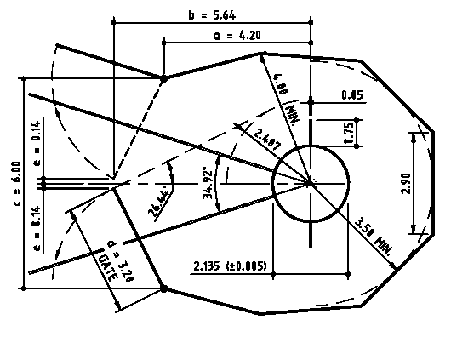

Hammer throwing cage with 3.2m gates (gate to be perpendicular to hammer throwing line) (Dimensions in m)

It is proposed that both these Regulations have a statement to the effect that they will be removed from 1 October 2021

Rule STR35 - Discus Cage (To be removed from 1 October 2021)
Rule STR37 - Hammer Cage (To be removed from 1 October 2021)

The Rules Committee seeks comment on these proposals before making a recommendation to the Board.
Rod Syme (Convenor), John McBrearty, Don Mackenzie, Andrew Orme
21 June 2020

